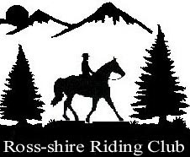

MEMBERSHIP FORM for 2025

Adult - £30
Junior - £20, (under 17yrs on 01.01.2020)
Non- Riding - £15 Life Members - £10
(The above memberships are for individuals only; more than one member will require either separate forms or family membership – as below.)
Family - £50, (2 adults and unlimited specified children living in same household)

Name & Address  (please write clearly in capitals where possible) | Post Code …………………...
E Mail Address

Home Tel Number

Mobile Number(s)

Membership  type required | Full Name  (inc d.o.b. for Junior) |  | £
 | Amount enclosed – |  | £
Cheques should be made payable to Ross-shire Riding Club and sent with completed form to:-
BRENDA BURNETT, 9, MOUNTHIGH, BALBLAIR, Nr, DINGWALL, ROSS-SHIRE IV7 8LH.
Bacs payment to 83-15-17 13980574
What are your interests p/c, s/j, trec etc |  | DATE………………………….
Ross-shire Riding Club depends entirely on volunteers, to help set up a show, during it, and clearing away afterwards. Any assistance you could give would be much appreciated.

Can we contact you prior to shows to help out? Yes/No

From time to time we would like to post photographs on our web site, we need your permission to do this. YES / NO

